  - Service Design
[Service Name]

  - [RITMXX / ACBSD-xxx]

Version control
Version | Date | Author/updated by | Status | Recommend | Comment
XX.YY.ZZ | YYYY-MM-DD

Contents
2. Related material 5
Architecture documents 5
3. Timeline 6
Related tickets 6
4. Distribution and contacts 8
5. Summary 10
Background 10
Preferred timeline 10
Business units impacted 10
Relative size, scope & impact 11
Stakeholders 11
6. Required artifacts 12
Architecture Delivery Scope 12
Non-Architect Review Processes & Acknowledgments 13
7. Enterprise Scope 14
Vision model 14
Value streams 14
Domain models & boundaries 14
Capability map 14
Shared responsibility model 14
RACI 14
Exit Strategy 14
Impacted Teams 15
Wardley map of components 15
8. Internal Compliance & Controls Requirements 16
Technology Risk Assessment (TRA) 16
Architecture Risk Exceptions 16
9. Security Requirements 17
Security review outcomes 17
Threat model 17
10. Data Requirements 18
Data Classification 18
Privacy Impact Assessment (PIA) 18
Data Encryption and Security Requirements 18
Data usage 19
Data Retention Requirements 19
Data residency 19
11. Estimated costs 20
Cost benefit analysis 20
Assumptions 20
Non-financial considerations 20
Other resource considerations 20
12. Service offering 21
13. Implementation approach 22
High level road map 22
Proposed Level of Coordination 22
14. Appendix 1: Related documents 23
15. Appendix 2: Glossary of terms / acronyms 24

Related material

Architecture documents
Associated documentation can be found at these links
- GTS Solution Design Repository
- Feasibility
- Service Design (this document)

Timeline

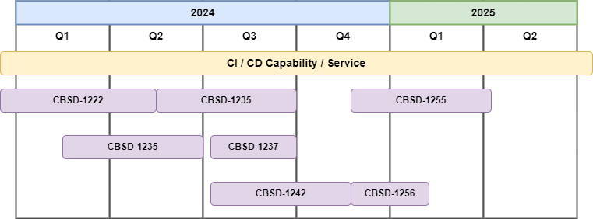

Related tickets
Below table shows inflight work related to this architecture / service

Feasibility | ARB Design Approval | ARB Final Approval | Summary
CBSD-1234 |  |  | Technology refresh
 | CBSD-1200 |  | Increase reliability of and cost effectiveness of the platform
 |  | CBSD1111  CBSD1112 | Add additional dashboard and alerting

Distribution and contacts
A copy of this document has been issued to those shown below and any updates will be circulated only to these individuals.

Business Contacts and Information
Requester
Business DPO
Business ISO
Business Architect
BCP Manager
Business Unit
Cost Center
Cost Center Owner
Product / Service Owner
GTS Contacts and Information
GTS DPO | Adam Kaminski
GTS ISO | Nick Russell & Daniel Lartey
GTS Architecture | Name of Assigned Architect
Technology Risk Assessment | Mark Scarloss
GTS Identity Mgmt. | Name of contact
GTS Network Svcs. | Mike Quint
Product / Service Owner | Name of contact

Summary

Background
Describe the Motivation(s) for initiating this work.

Describe the capability being addressed

Describe the Drivers and Constraints from the Vision (see chapter Enterprise Scope: Vision Model)

Preferred timeline
Document the preferred business timeframes and what is driving the timeline (regulatory, project dates etc.)

Relative size, scope & impact
See the Project Management Intake Score Sheet for details

Stakeholders

Table of stakeholders and their roles
Role | Stakeholder | Comment

Required artifacts

Architecture Delivery Scope

In Scope | Owner | Architecture Artifacts  Link to Templates
¨ | GTS - Architecture | Architecture Feasibility Assessment
¨ | GTS - Architecture | Service Design Document
¨ | GTS - Architecture | Solution Design Document
¨ | GTS Architecture | Component Architecture Standard
¨ | GTS Architecture | Architecture Design Pattern
¨ | GTS Architecture | Reference Architecture
¨ | GTS - Architecture | Architecture Solution Design – POC ARB
¨ | GTS - Architecture | Architecture Solution Design – Design ARB
¨ | GTS - Architecture | Architecture Solution Design – Final ARB
¨ | GTS - Architecture | Architecture Solution Design – Exception ARB
¨ | GTS - Architecture | Architecture Solution Design - Software / Hardware Acquisition ARB

Non-Architect Review Processes & Acknowledgments

In Scope | Owner | Non-Architecture Review / Assessment Process | Point of Contact | Link to Acknowledgement or Evidence
¨ | GTS – Internal Compliance & Controls | GTS Technology Risk Assessment | Mark Scarloss | Link
¨ | GTS - Infrastructure | GTS Infrastructure Review |  | Link
¨ | GTS – Information Security | GTS Information Security Review | Nick Russel, Chad Hunter, or Jeff Bain | Link
¨ | GTS – Data Privacy | GTS Data Privacy Review | Adam Kaminsky | Link
¨ | GTS – Data Privacy | GTS Data Privacy Impact Assessment | Adam Kaminsky | Link
¨ | Requester | LDA/BU Architecture Acknowledgement |  | Link
¨ | Requester | BISO Acknowledgement |  | Link
¨ | Requester | Procurement Third Party Risk Assessment |  | Link
¨ | Requester | Procurement Process Completed |  | Link
¨ | GTS - Architecture | Approved Architectural Artifacts Added to Architecture Repository | Assigned Architect | Link

Enterprise Scope

Vision model
The example below is taken from the ArchiMate Cookbook, section 2.1.1:
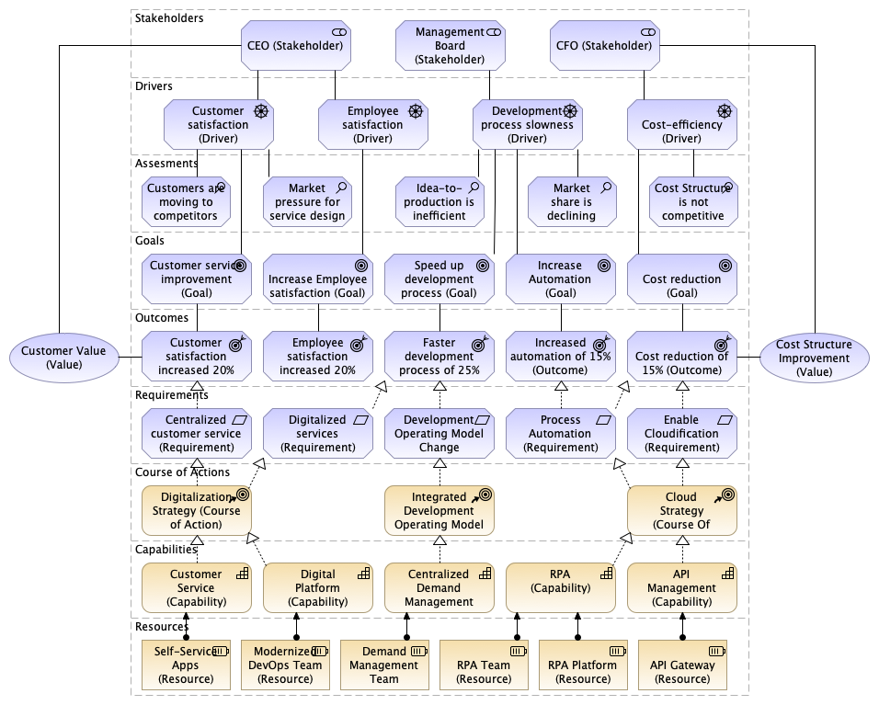

Value streams
List the Value Outcomes from the Vision model and describe how they are being met.

Value stream maps
Use ArchiMate to develop a model relating Capabilities, Processes and Goals to Value
See the examples and guidance in the ArchiMate Cookbook section 2.2.3
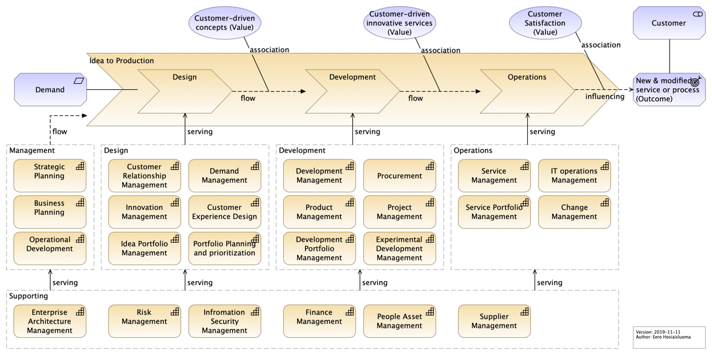

Domain models & boundaries

Capability map
See 2.2.4.1 Capability Map View in the Archimate Cookbook

Shared responsibility model
Consider allocating responsibility for different components, risks, processes and artefacts.
This is especially important if responsibility is split between business units, or Aegon and third party providers.
Cloud architectures should make special reference to the cloud service provider’s shared responsibility model.
ACE should also provide a shared responsibility model.

RACI
Below is a template for a comprehensive RACI. A more focussed version will usually suffice.
Other stakeholders might include ICC (risk), Chief Data Officer, CTO and CEO.
Key Activity, Milestone or Decision | Business Units | Global Enterprise Architecture | Global Infrastructure Platform Engineering | Global Information Security Services | BISO
Application Security Governance
Own Application Security capability | C/I | C/I | C/I | R/A | C/I
Define and maintain (adoption) strategy | C/I | R/A | C/I | R/A | C/I
Communicate (adoption) strategy | C/I | C/I | C/I | R/A | C/I
Define and maintain roles & responsibilities | C/I | C/I | C/I | R/A | C/I
Align Security strategy with Business Objectives | C/I | C/I | C/I | R/A | C/I
Define and describe policies & standards | C/I | C/I | C/I | R/A | C/I
Define application security objectives | C/I | C/I | C/I | R/A | C/I
Architecture
Create Tooling Architecture | C/I | R/A | C/I | C/I | C/I
Arrange ARB approval | C/I | R/A | C/I | R/A | C/I
Tooling implementation & Maintenance
Define tooling requirements | C/I | C/I | C/I | R/A | C/I
Select tools | C/I | C/I | C/I | R/A | C/I
Arrange required budget for tooling licences | C/I | C/I | R/A | C/I | C/I
Arrange required budget for resources maintaining tools |  |  | R/A | C/I | C/I
Implement and maintain tools | C/I | C/I | R/A | C/I | C/I
Implement required integrations | C/I | C/I | R/A | C/I | R
Conduct license management | C/I | C/I | R/A | C/I | C/I
Implement required reporting | C/I | C/I | R/A | C/I | C/I
Automate manual and repeatable activities | C/I | C/I | R/A | C/I | C/I
Deliver standard pipeline scanning building blocks | C/I | C/I | R/A | C/I | C/I
Organise DevSecOps community sessions | C/I | C/I | R/A | C/I | C/I
Training, Education & Roll Out
Identify and deliver training capabilities | C/I | C/I | C/I | R/A | C/I
Conduct developer training | R/A |  | C/I | C/I | C/I
Conduct security officer training | C/I |  |  | C/I | R/A
Conduct security awareness sessions | C/I | C/I | C/I | R/A | C/I
Conduct DevSecOps assessment per BU | C/I | C/I | C/I | C/I | R/A
Deliver Improvement plan as outcome of DevSecOps assessments | C/I |  |  | C/I | R/A
Ensure sufficient time is availablle for vulnerability remediation | R/A |  |  |  | C/I
Check scanning reporting results | R |  |  |  | R/A
Escalate to management if right follow up on scanning results and reporting is lacking | C/I |  |  | C/I | R/A
Scanning and mitigation
Conduct scanning | R/A |  | C/I | C/I
Prevent and resolve software security issues | R/A |  |  |  | C
Request false positive or exception check if required | R/A |  |  |  | C/I
Judge outcome false positive or exception requests | C/I |  |  |  | R/A
Administer outcome in ServiceNow VR | C/I |  |  |  | R/A

Exit Strategy
If we need to move to a different solution (for commercial or other reasons) describe the alternative options

Business units impacted

The following Country/Business Unit(s) will be impacted by this Solution Design
◻ | TA Individual | ◻ | Spain
◻ | TA Workplace | ¨ | HR Global
◻ | TA Finance | ◻ | ASIA/TLB
◻ | TA | ◻ | Corporate Centre
◻ | UK | ◻ | CEE
◻ | NL | ◻ | AAM
þ | GTS | ◻ | Other

Wardley map of components
This section is currently optional. Submissions must be reviewed by GEA leadership team before submission to ARB
Use this section to map common, core and distinct capabilities
The X-axis is Core Common and Distinct
The Y-axis shows arbitrary value
See the example Wardley Map here.

Definitions:
Core: Essential services used by all business units without exceptions. They are items that are the foundation upon which everything else depends.
Common: Services used by many, possibly all business units, with the expectation of adoption unless a strong justification exists. They're important but not necessarily universal.
Distinct: Services used by specific business units or serve as their unique differentiators. These are specialized capabilities tailored to individual needs.

Internal Compliance & Controls Requirements

Technology Risk Assessment (TRA)
The technology risk assessment findings should be documented here. The assigned architect will work with Mark Scarloss to complete the technology risk assessment for the solution.

Architecture Risk Exceptions
GTS Architecture Review Board (ARB) provides a governance framework for Architecture Risk. The GTS ARB will review and approve / reject solution Architecture Risk Exceptions.
Link to Risk Exception within Architecture Risk Exception Register

Security Requirements
Minimum security requirements are defined by the application risk rating (high, medium, low) for technology components identified within section 4.3. See Minimum Security Requirements by App Risk Rating - Architecture Requirements.pptx for the minimum security requirements.

Security review outcomes

Detail any significant outcomes, risks or recommendations highlighted in the security review
See the Security Review here

Threat model
See threat modelling guidance here: XXXXXXX
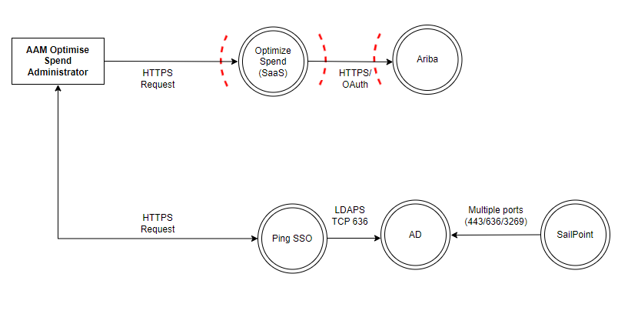

Data Requirements

Data Classification

Data Confidentiality Classification |  | Data Legal and Regulatory Classification
¨ | Strictly Confidential | ¨ | Financial Information
¨ | Confidential | ¨ | Personal Identifiable Information
¨ | Internal | ¨ | Protected Health Information
¨ | Public | ¨ | Payment Card Information
¨ | No Data Shared | ¨ | No Personal Data Shared

Privacy Impact Assessment (PIA)
Work with the Data Officer to assess the potential impact on the privacy of individuals.

Data Encryption and Security Requirements
Describe the requirements data encryption at rest and in transit. Refer to data security requirements for minimum requirements for data encryption and security. If data is not in scope for the solution, then state N/A.
Eg Data in transit is being encrypted via SSL TLS1.2 at minimum

Data usage
Describe the data usage requirements to be considered when architecting the solution. If data is not in scope for the solution, then state N/A.

Data Retention Requirements
Describe unique data retention requirements to be considered when architecting the solution. If unique data retention requirements are not in scope for the solution, then state N/A.

Data residency
Describe data residency requirements to be considered when architecting the solution. If data residency requirements are not in scope for the solution, then state N/A.

Estimated costs
This is an estimate of the likely cost of the solution, based on the known scope and requirements. This cost contains an estimate of the labor required to implement the solution, and the ongoing annual running cost of the solution with the servers turned on 24/7. This is not a quote and is subject to change if new information becomes available, the scope or requirements change, or if GTS’s service offerings and rates change.

Cost benefit analysis
Example cost benefit analysis table:
Compare proposed service / capability / solution against the as-is scenario.
If possible, also against any closely matched alternative solutions.
Values in USD m
Current Form |  | 2023 | 2024 | 2025 | 2026
Internal | Existing 0.5 FTE | 0.079 | 0.079 | 0.079 | 0.079
External | New 1.0 FTE | - | 0.159 | 0.159 | 0.159
Solution A | Infrastructure agtawsaus | 0.032 | 0.032 | 0.032 | 0.032
Ext’ Service | AWS Config | - | 0.720 | 0.720 | 0.720
Total |  | 0.159 | 1.037 | 1.037 | 1.037
Proposed New Form [Assumes 1 Jan '24 start date] |  | 2023 | 2024 | 2025 | 2026
Solution B | Licence / subscription | - | 0.250 | 0.214 | 0.214
Internal | Existing 0.5 FTE | 0.079 | 0.079 | 0.079 | 0.079
External | 6 Month contractor | - | 0.150 | - | -
Solution B | Infrastructure | 0.032 | 0.016 | - | -
Cloud Security | AWS Config | - | 0.360 | 0.360 | 0.360
Total |  | 0.159 | 0.879 | 0.653 | 0.653
Cost Differential |  |  | 0.158 | 0.384 | 0.384
 |  |  | 2024 | 2025 | 2026
Run | Current |  | 1.037 | 1.037 | 1.037
 | New |  | 0.729 | 0.653 | 0.653
 | Delta |  | 0.308 | 0.384 | 0.384
 |  |  | 2024 | 2025 | 2026
Build | Current |  | - | - | -
 | New |  | 0.150 | - | -
 | Delta |  | -0.150 | - | -

Assumptions

Non-financial considerations

Other resource considerations

Service offering
This section to be completed at a later date. Suggestions welcome

Implementation approach

High level road map
Describe the activities leading the delivery:
- Maturity model
- Which capabilities; in what order?

Proposed Level of Coordination
Describe how GTS will coordinate delivery with customers, other BU’s and third parties.
Examples of what could go here:
- Customer to submit launch requests:
  - External Business Partner Connection
  - Firewall Request (optional)
  - Web Security Management
  - File Transfer Request
(Delete items that are not part of the solution)
- Other BU components
- Existing and new services
- Existing and new project dependencies

Appendix 1: Related documents

Appendix 2: Glossary of terms / acronyms

Data Classification (ITCF Definitions)

